Navigating AwardSpring:
Reviewer Guide

Navigate to the URL provided to you by the organization’s administrator to log in with your email address and password.

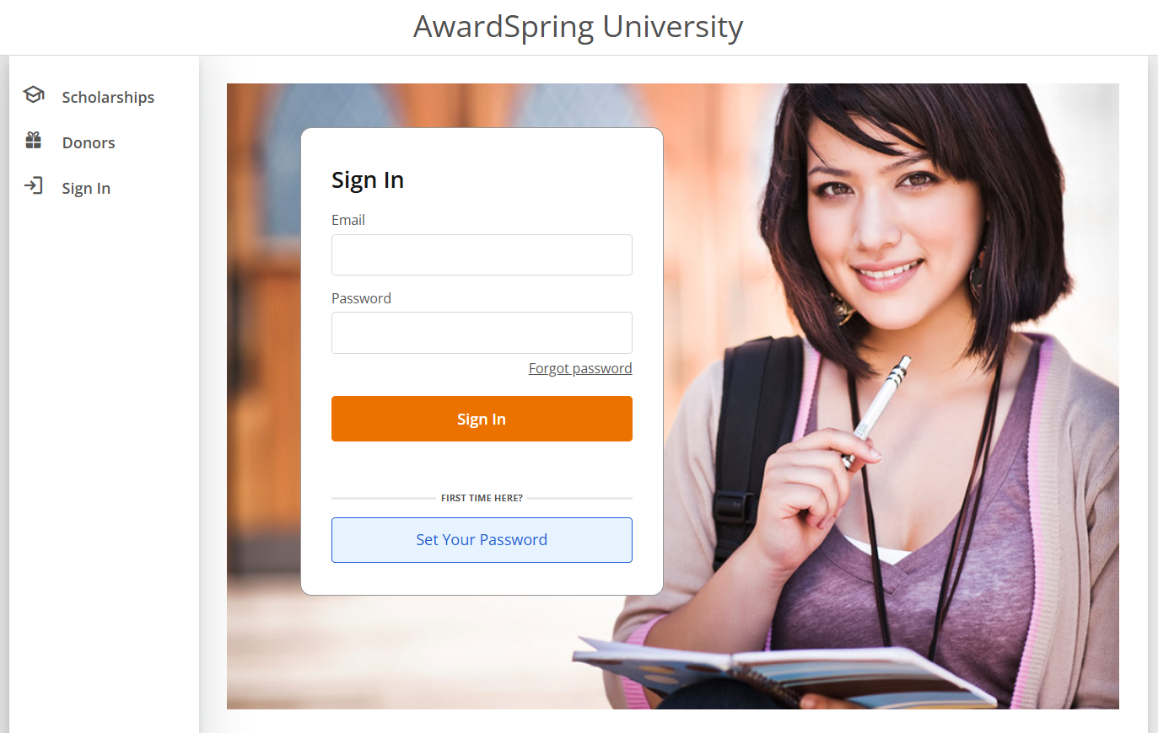

If you do not yet have a password or have forgotten your password, click on the “Forgot Password” button.
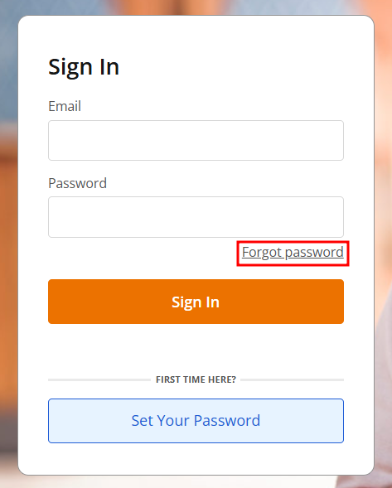

Enter your email address and click on “Reset Password”.
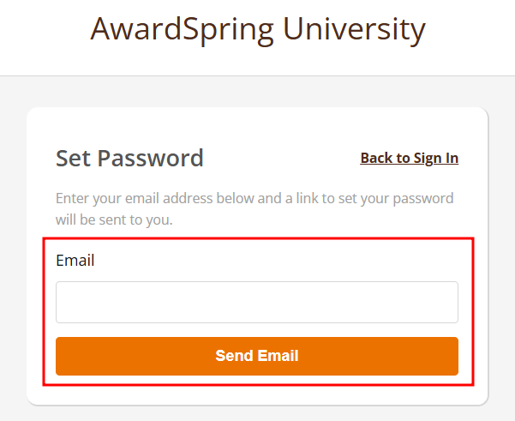
Check your email for a message entitled “AwardSpring Password Reset”. Note that the password reset link will expire after 24 hours.
If you do not see this email in your inbox, please check your Junk/Spam Folder(s).
Click on the “Reset Password” in the middle of the message or copy and paste the link at the bottom of the email into your web browser address bar.
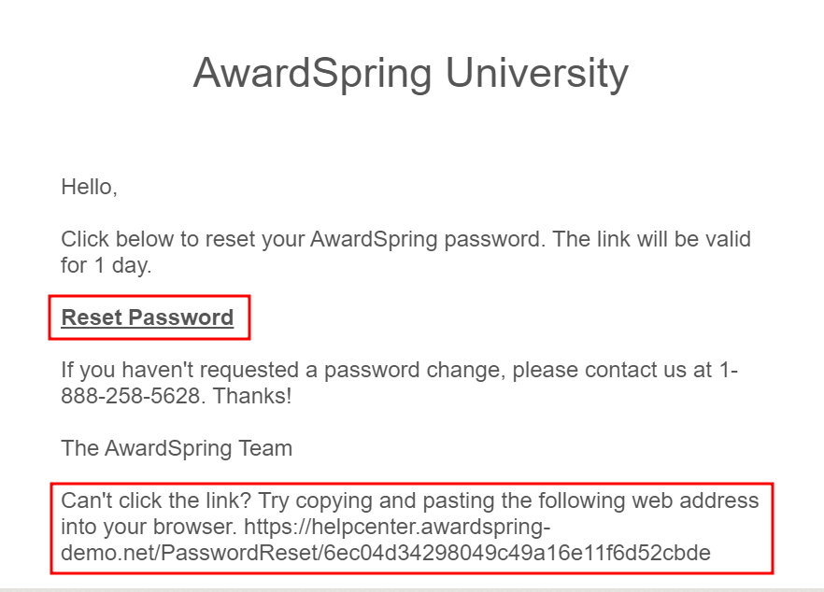

Enter your password on the screen twice and click on “Reset Password”.
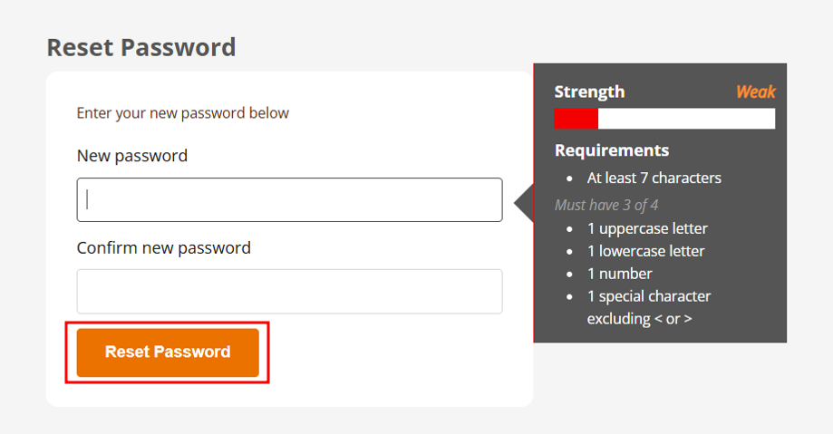
You will now be directed to the Privacy and Policy Use agreement page. Please read the policies and click the checkbox next to “I agree to the AwardSpring Terms of Used and Privacy Poicy” and then click “Accept Agreement”.
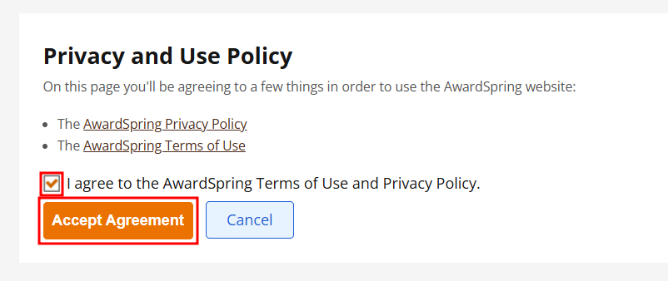

You will be brought to your dashboard which displays a list of review groups. These are the review groups to which you have been assigned.
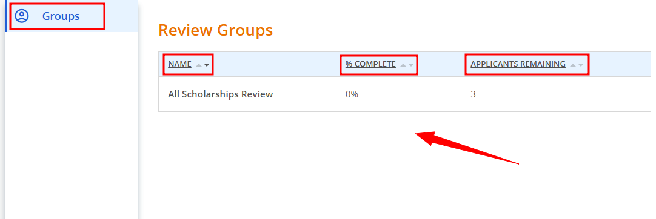

Also, you will see percent complete (reviewed) and the number of applicants remaining to be scored. Click the arrows next a column header to order (ascending or descending) by that particular value.

You can begin scoring by clicking on a Group Name. You will be taken to the Applicant List page where you can see all the applicants who have applied for the scholarships in the selected group. StudentID data will display next to the applicant names, alongside the Review Status column and Score column. Again, the sorting option is available for each column.

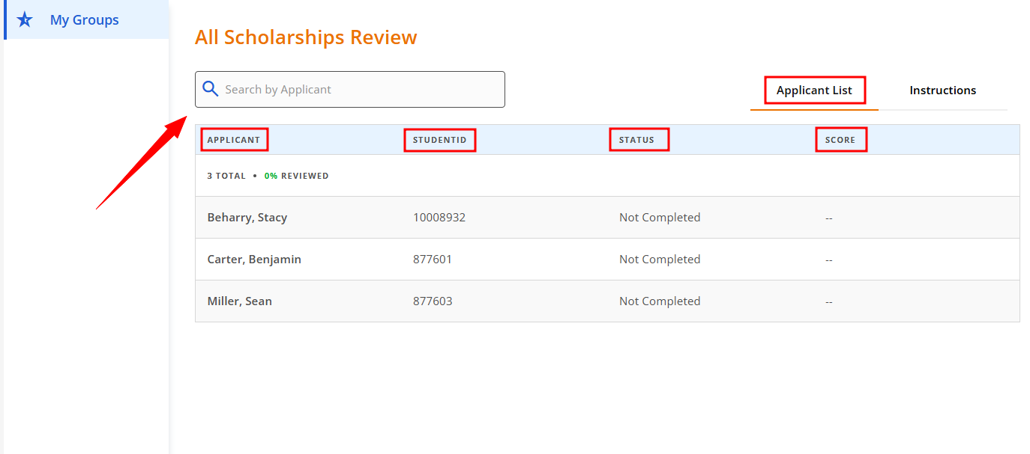

Click on an applicant to begin reviewing their application. Below is an example of a student that is ready to be scored.

You’ll notice that the score board will populate on the right side of the screen, with a score card for every critieria that the student needs to be scored on.

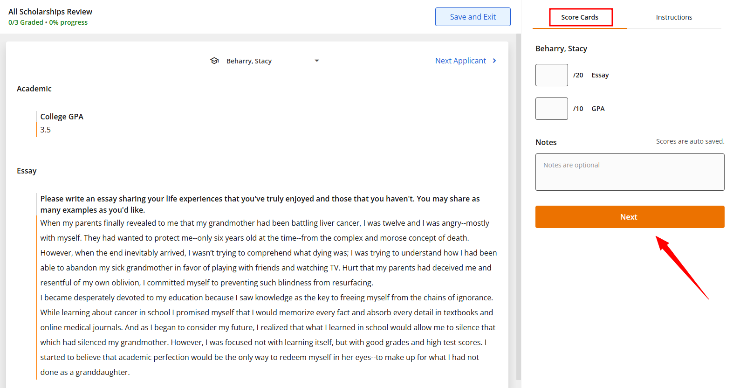

You’ll also have access to instructions that the Admin team added for you under the Instruction tab, located on the right side of the screen.

After you have completed scoring an applicant, click the “Next Applicant” to proceed with reviewing the next applicant.
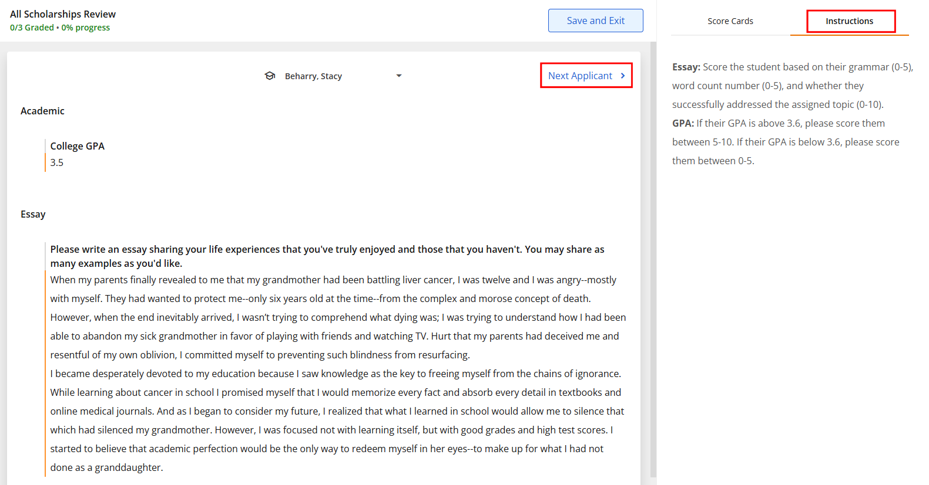

Once you have finished scoring, you can click the “Save and Exit” button.

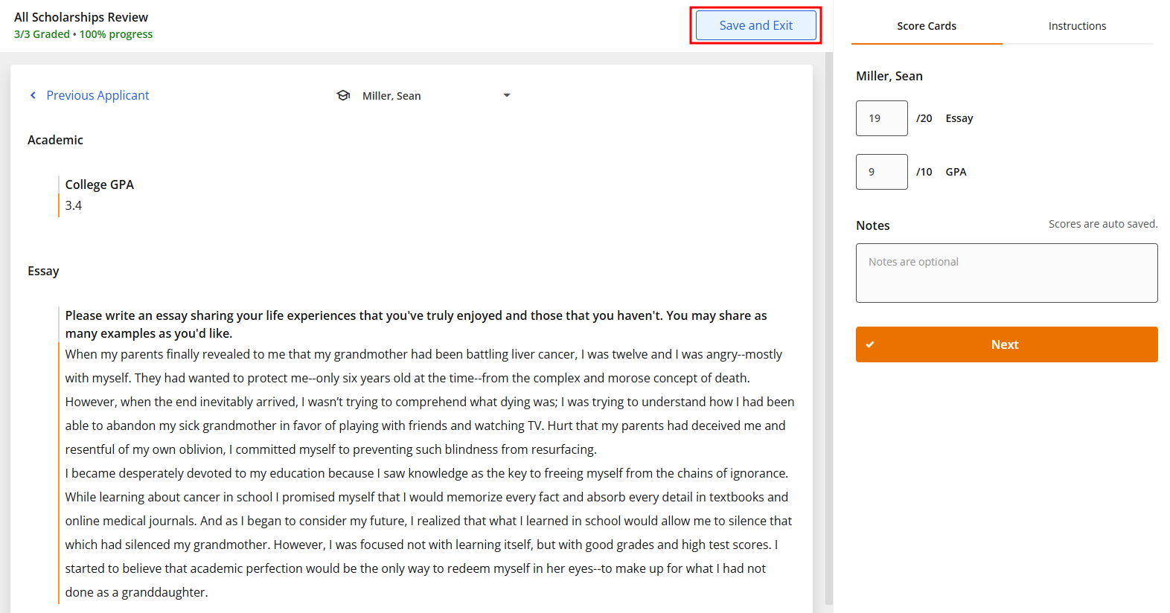

The Groups tab will show 100% complete and 0 applicants remaining.

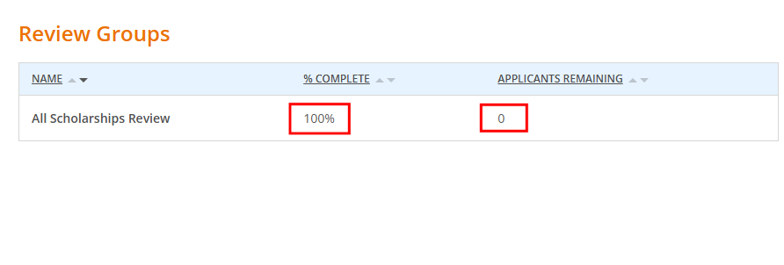

Select the drop down menu at the top right of the screen to log out of your account.
