Navigating AwardSpring:
A Guide for Applicants

The purpose of this guide is to walk you through the process of applying for scholarships using the AwardSpring platform.
Start by navigating to your organization’s AwardSpring site. The URL will be provided to you by your organization’s administrator.
You will land at the login page. (Please note that this page is customizable so your organization’s login page may look different than the below example.)
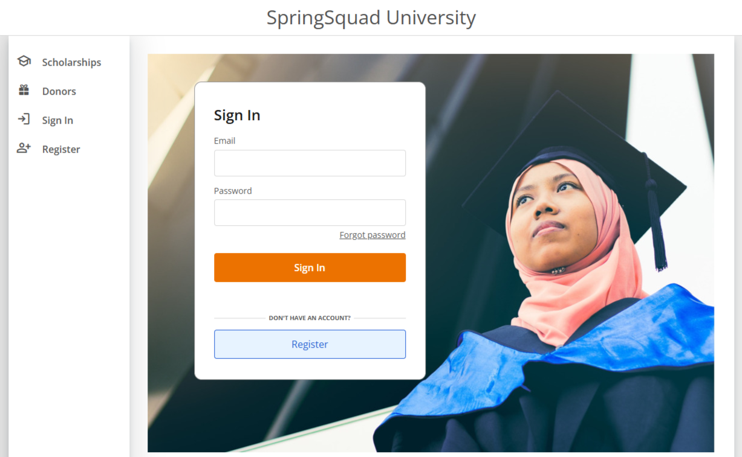

In the left menu bar, both Scholarships and Donors are clickable buttons.
Scholarships will show you a list of all scholarships that are being offered by your organization along with their respective award amounts (if known) and deadlines.
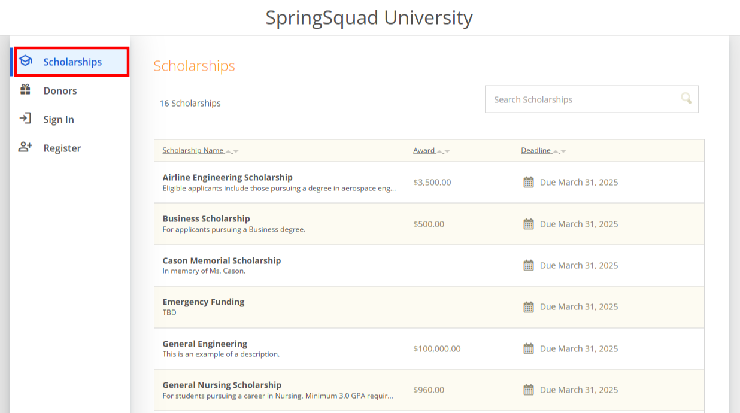
Click into a scholarship to see additional information.
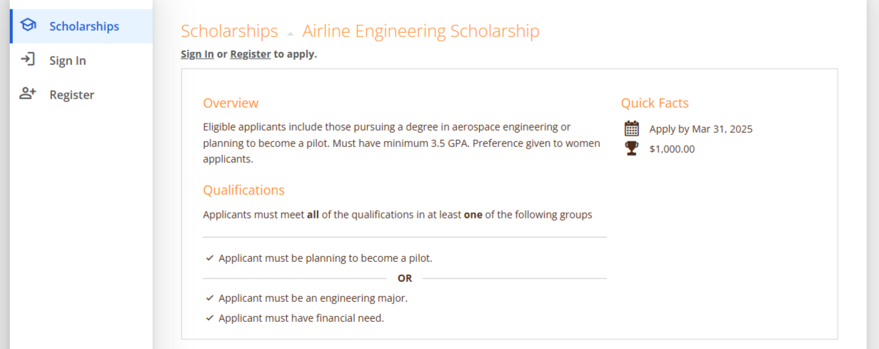

Click Donors to view profiles of the donors and the scholarships they are sponsoring.
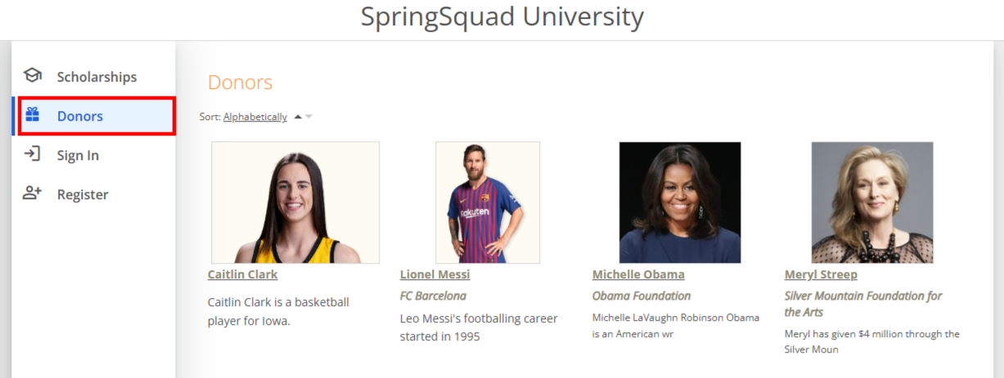
Click into to a Donor page to see additional information.
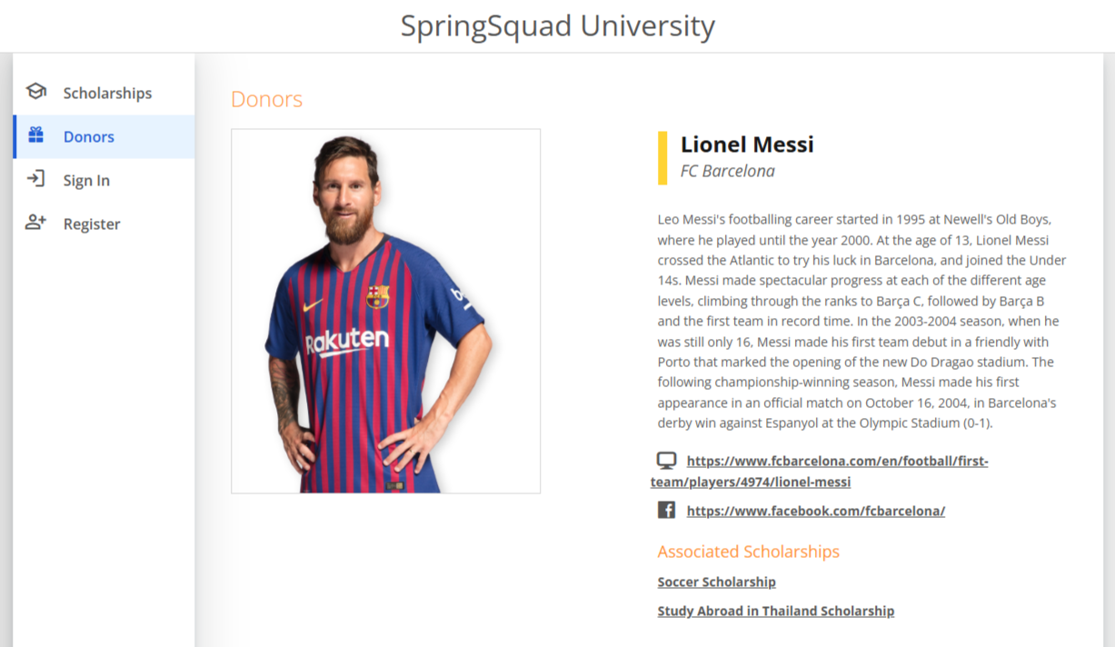

TO LOG IN:
Sign In: Use if you already have an account. Enter your email address and password and click the yellow Sign In button.
Register: Use if you do not have an account. You will be directed to a registration page. Enter all of the required information, click the agreement box, and click the Create Account button.
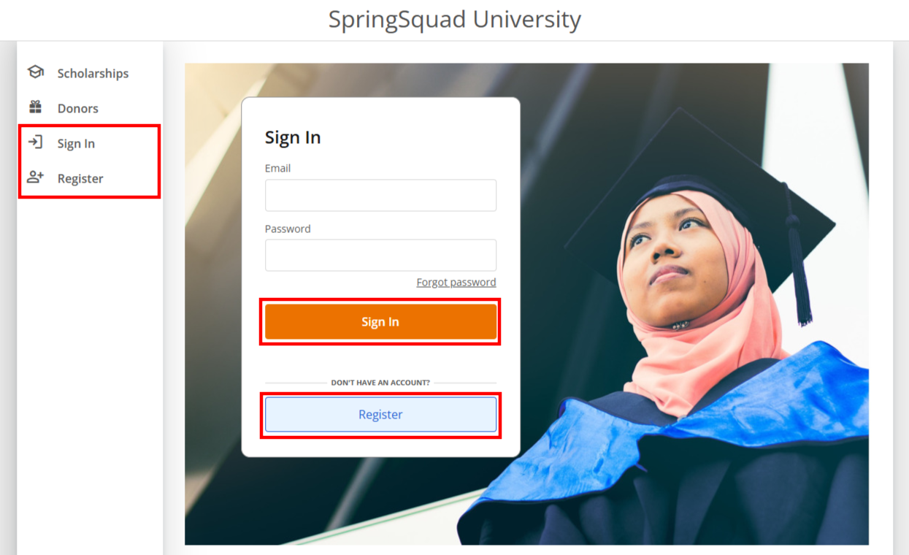
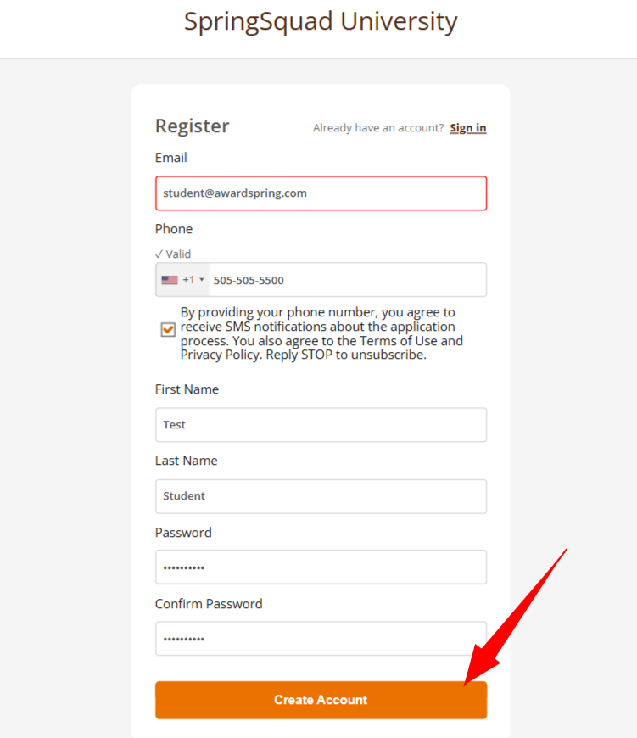
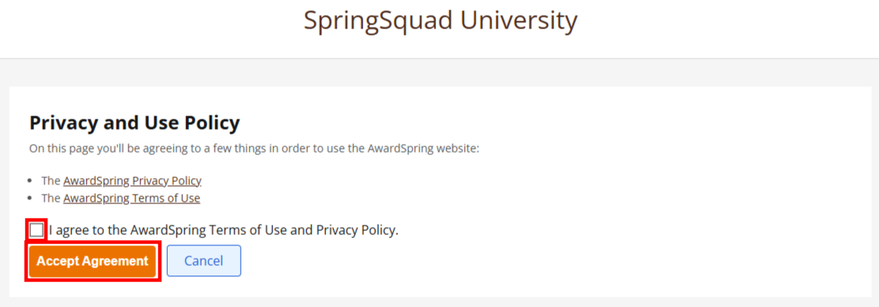

After login/registration, you will be directed to your Dashboard. Important information about your application status and additional instructions will be displayed for you here.
To start filling out your general application you can click either one of the following buttons on your dashboard: Application tab, Apply, or Complete.
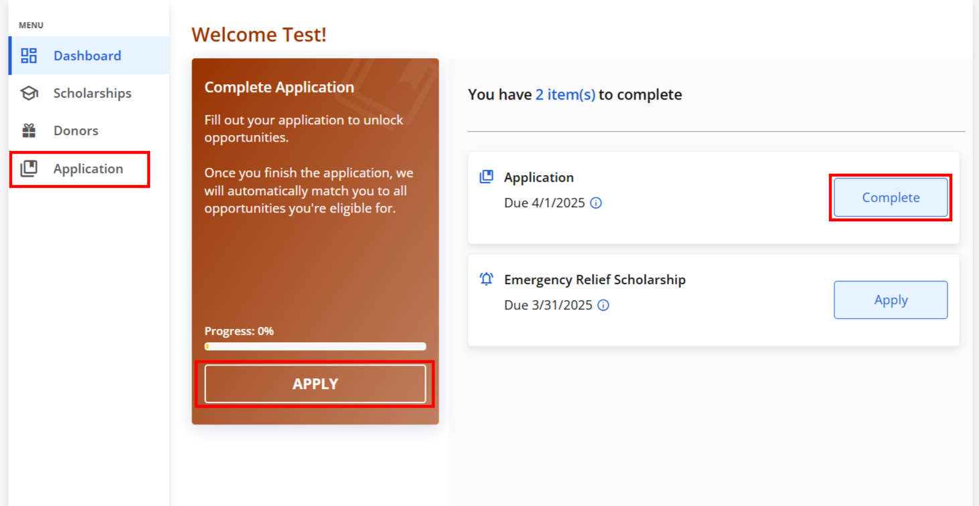

There are several sections that make up the entire application. Complete all of them in order to submit your application.
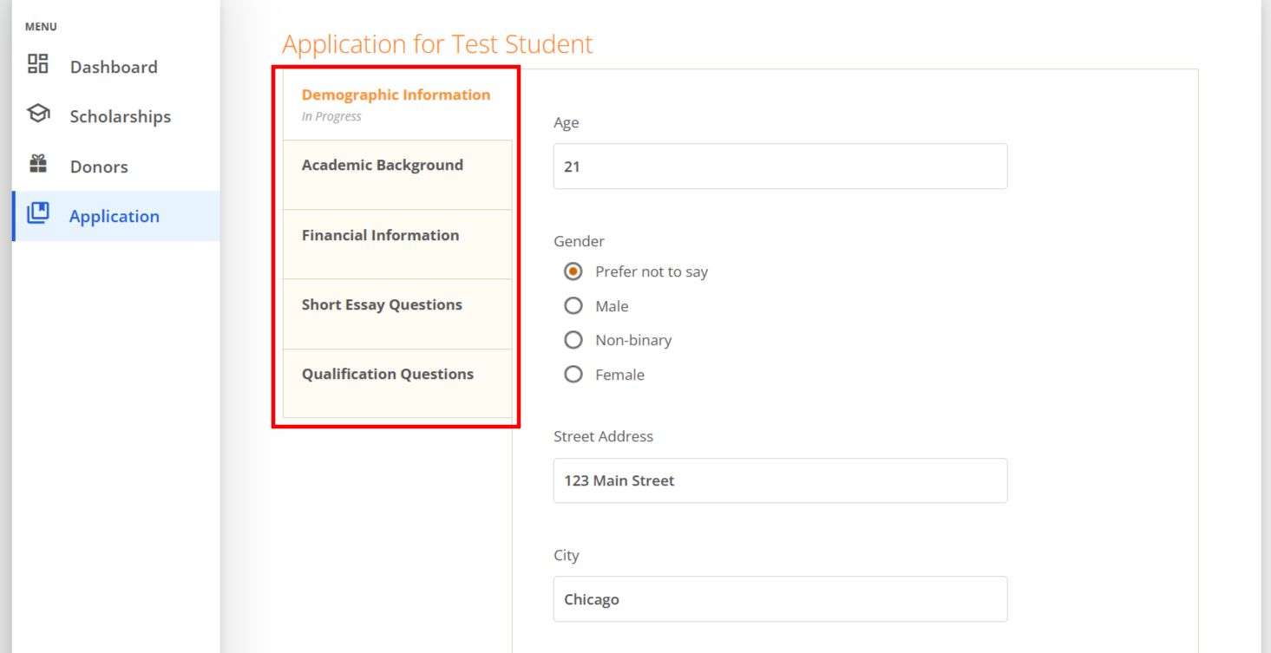

You may see an embedded External Request form that requests information from a third party (i.e. a letter of recommendation from an instructor). This tool allows you to send a request for a letter of recommendation via email. The application may contain more than one External Request form.
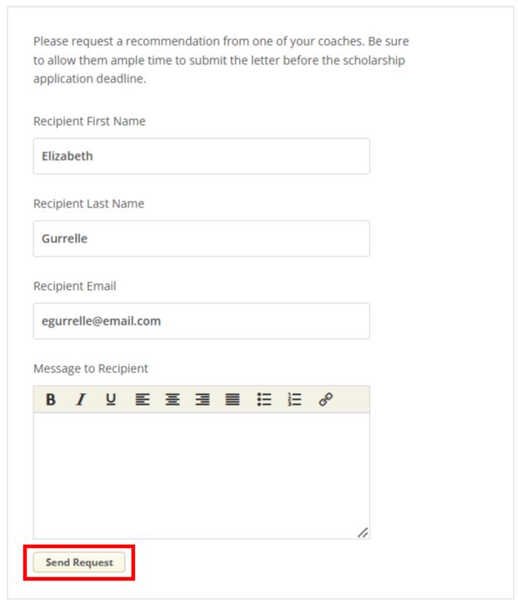
Complete the required information and click the Send Request button. The third party will receive an email request and provide the requested information directly in AwardSpring.
The request will sit in a pending state until it is completed by the recommender.
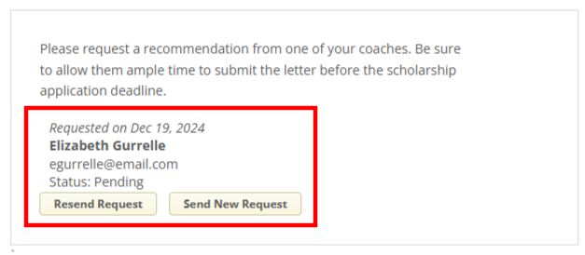
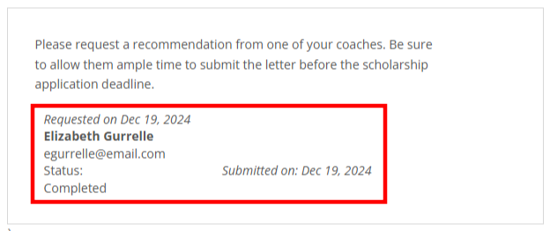
Completing all tabs of your application will enable to the Submit Application button in the lower right corner. Click it to submit your application, after that you will be redirected to your dashboard.
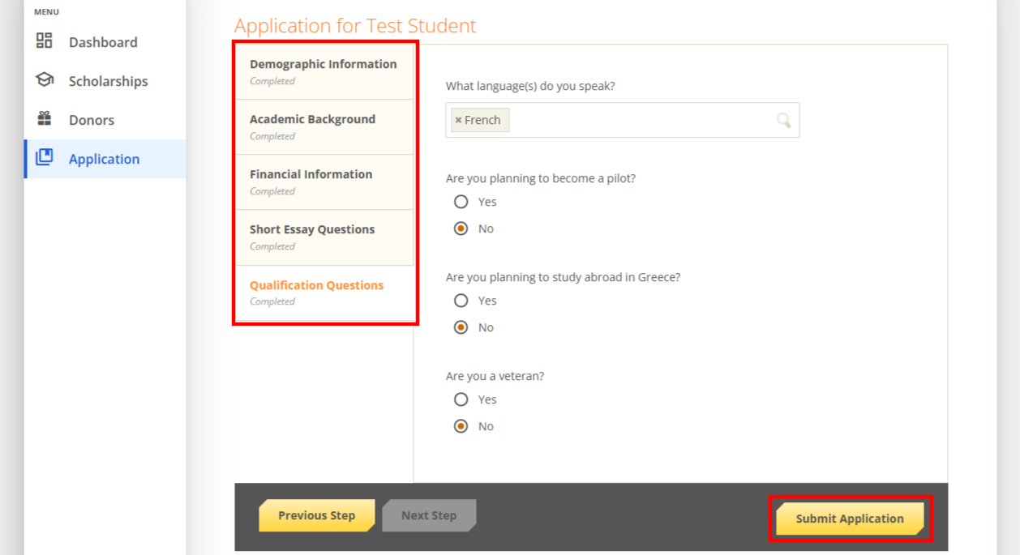

To view your qualifying statuses for scholarships click on the Scholarships tab, and reference the Status column.
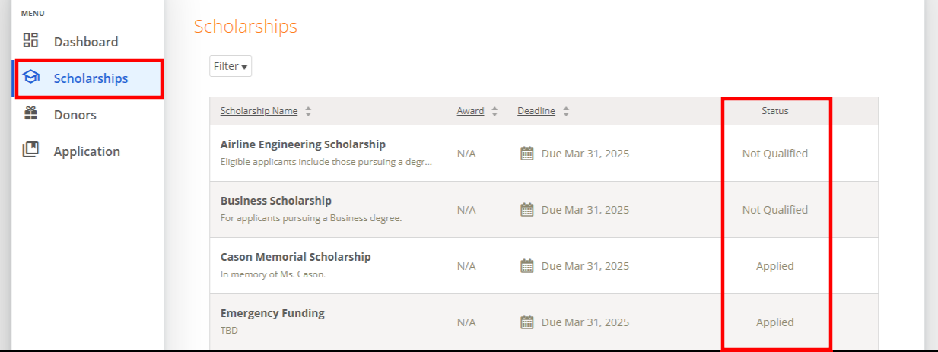
Click the Dashboard tab to return to your dashboard to view additional information or take further action.
You may be eligible for additional scholarships that require additional information. The dashboard will prompt you to complete these next steps.
In this example, the applicant qualifies for the General Engineering scholarship and Marcus Lashford Soccer scholarship, but additional follow-up information is required to apply for them. The applicant needs to click the Complete button to provide the required responses and/or documentation.
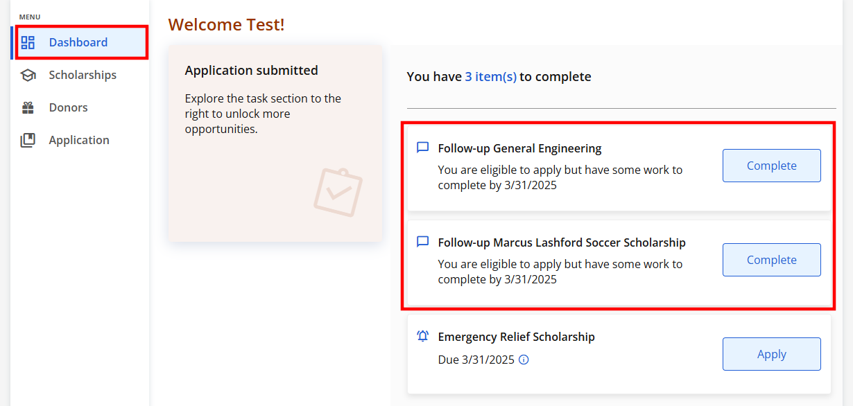

In this example, the applicant needs to respond to an essay question to finish applying for the scholarship.
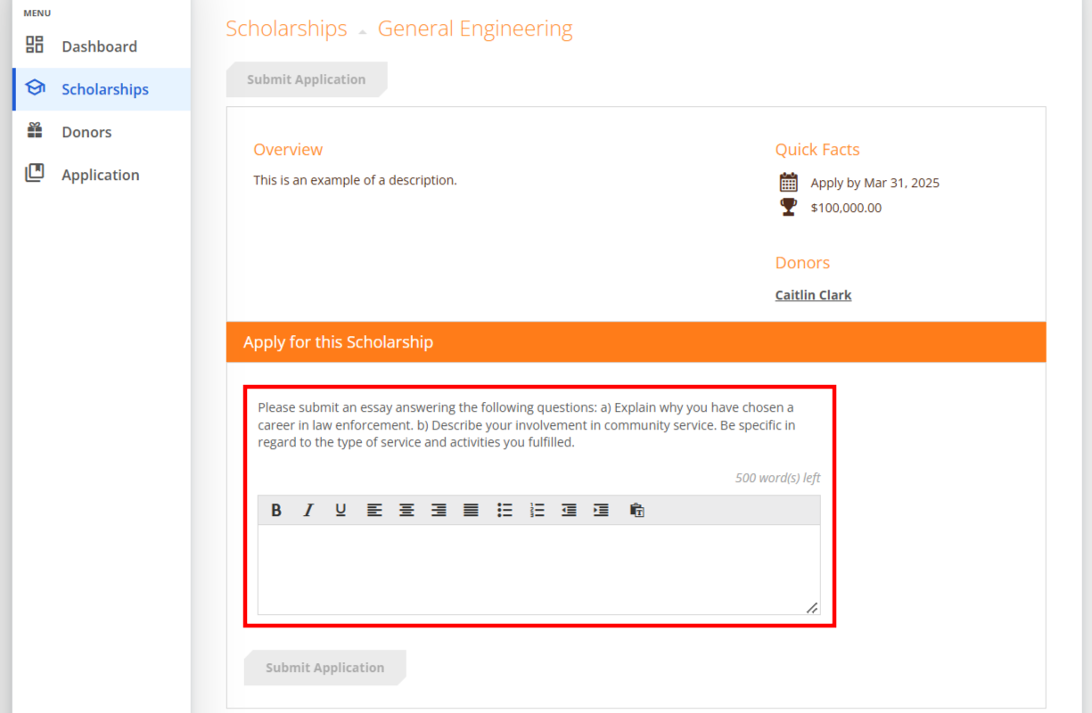
After completing all questions for the scholarship, click the Submit Application button to submit your application. Proceed through all Follow-Up items for all scholarships listed.
You may see an additional follow up item on your dashboard for an Emergency Fund. These items are optional for completion and are available to applicants whether they submitted the general application or not.
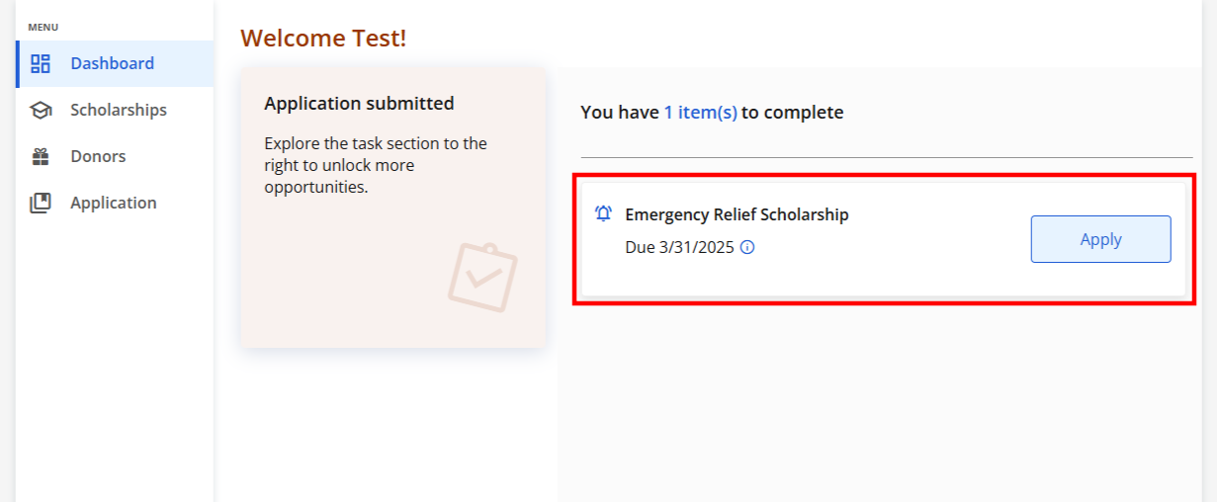
You can proceed to complete this item on your dashboard as well. If you choose not to, it will stay on your dashboard, and your work will be considered done.
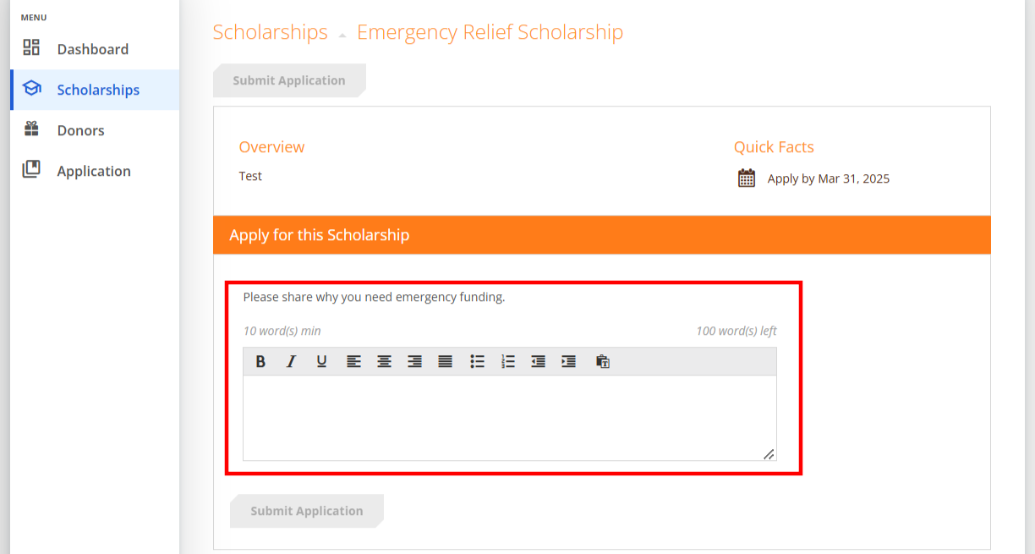

However, if you choose to apply for the Emergency Fund, your dashboard will be cleared of tasks. At that point you are all set! Your organization’s administrator will provide you further direction if it is needed.
